
ï¿½ï¿½ï¿½ï¿½ï¿½!
ï¿½Ñï¿½ï¿½...
ï¿½ï¿½ï¿½ï¿½ï¿½ï¿½ï¿½ ï¿½ï¿½ï¿½ï¿½ï¿½ï¿½ï¿½ï¿½ï¿½ ï¿½Çï¿½ï¿½!
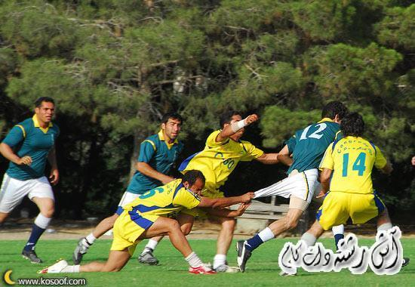
ï¿½ï¿½ï¿½ ï¿½ï¿½ï¿½ï¿½ ï¿½ï¿½ ï¿½ï¿½ï¿½ï¿½!
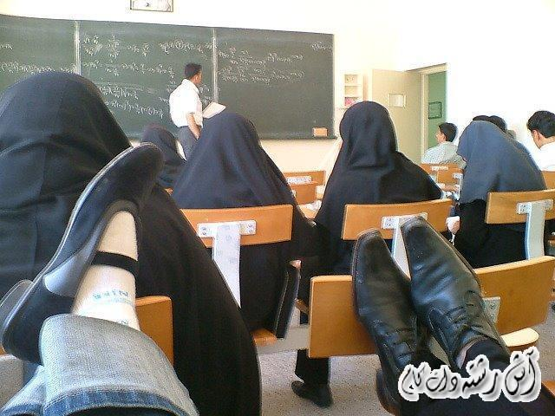
ï¿½ï¿½ï¿½ï¿½ ï¿½ï¿½ ï¿½ï¿½ï¿½ï¿½ ï¿½ï¿½ï¿½ï¿½ï¿½ ï¿½ï¿½ ï¿½ï¿½ï¿½ ï¿½ï¿½ï¿½ï¿½ï¿½ï¿½ ï¿½ï¿½ï¿½ï¿½ï¿½ ï¿½ï¿½ï¿½ï¿½!
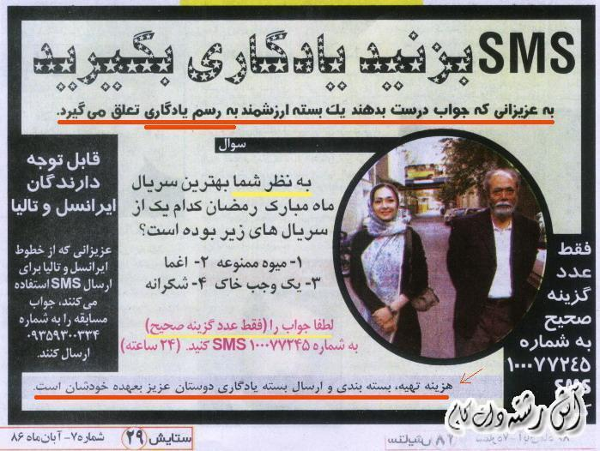
ï¿½ï¿½ ï¿½ ï¿½ï¿½ï¿½ ï¿½ï¿½ï¿½ï¿½!
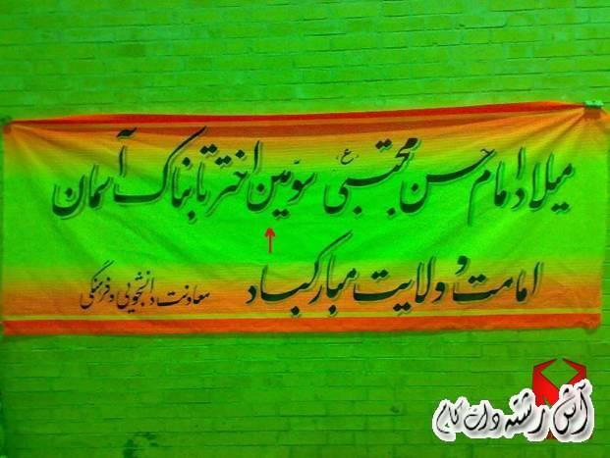
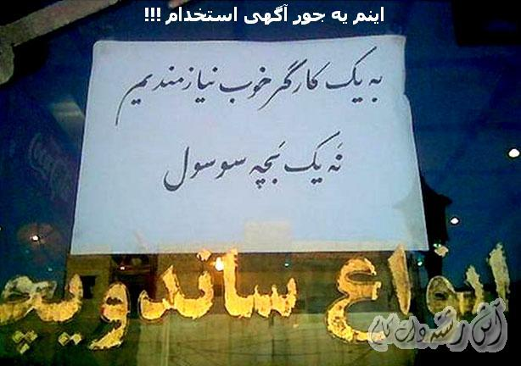
ï¿½ï¿½ ï¿½ï¿½ï¿½ï¿½ ï¿½ï¿½ï¿½ï¿½ï¿½ï¿½ï¿½ ï¿½ï¿½ï¿½ï¿½ï¿½!

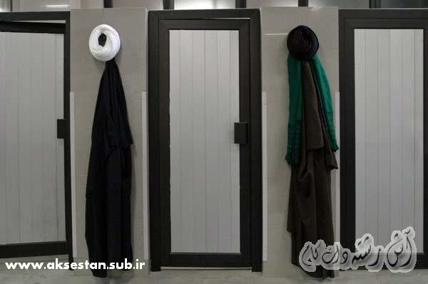
ï¿½ï¿½ï¿½ ï¿½ï¿½ï¿½ ï¿½ï¿½ï¿½ï¿½ï¿½ï¿½!
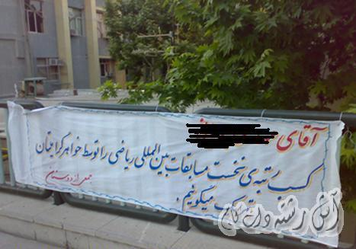
ï¿½Ñ˜ï¿½ ï¿½ï¿½Ñ˜ ï¿½ï¿½ï¿½ ï¿½ï¿½ï¿½ï¿½ ï¿½ï¿½ï¿½!
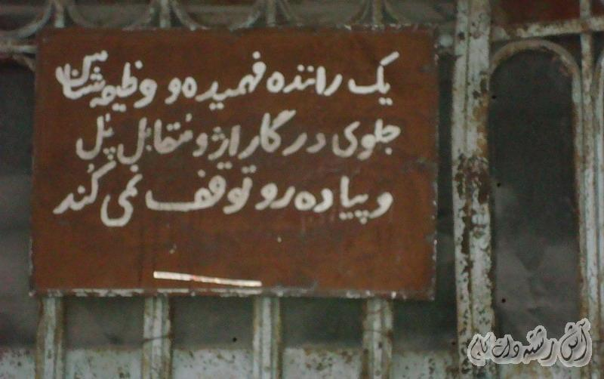
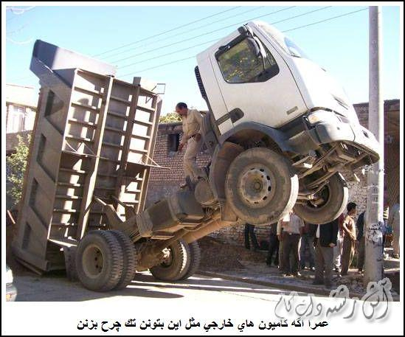
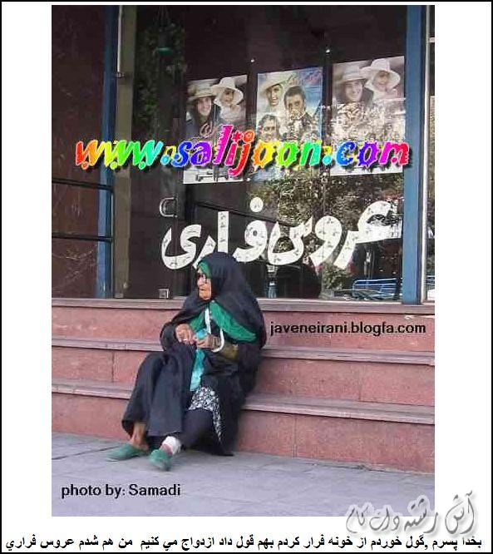
ï¿½ï¿½ï¿½ï¿½ï¿½ ï¿½ï¿½ï¿½ï¿½ï¿½!
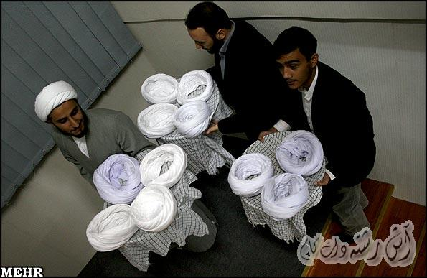
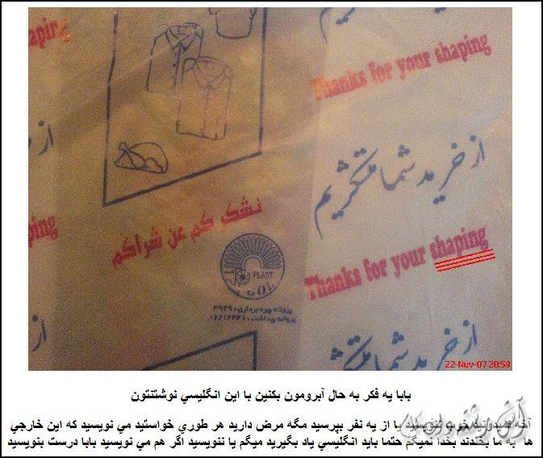
ï¿½ï¿½ ï¿½ï¿½ï¿½ï¿½ ï¿½ï¿½Ñ¿!
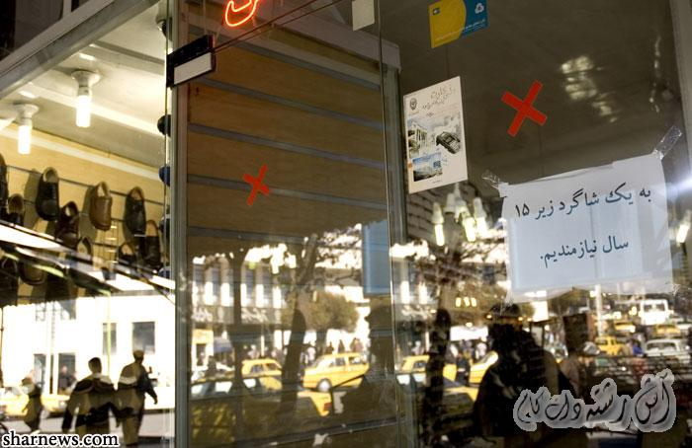
ï¿½ï¿½ï¿½ ï¿½ï¿½ï¿½ï¿½ ï¿½ï¿½ï¿½ï¿½
ï¿½ï¿½ï¿½ï¿½ï¿½ï¿½ï¿½ï¿½ ï¿½ï¿½ï¿½ï¿½ ï¿½ï¿½ï¿½ï¿½ ï¿½ï¿½ ï¿½ï¿½ï¿½ Ý˜ï¿½ ï¿½ï¿½ ï¿½ï¿½ï¿½ ï¿½ï¿½ ï¿½ï¿½ ï¿½ï¿½ï¿½ï¿½ï¿½ ï¿½ï¿½ï¿½ï¿½ ï¿½ï¿½ï¿½ï¿½ï¿½ï¿½ ï¿½ï¿½ï¿½ï¿½ï¿½ï¿½!
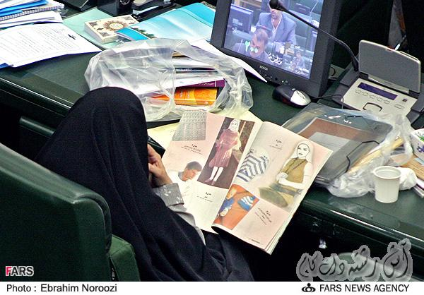
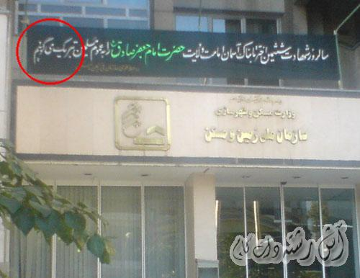

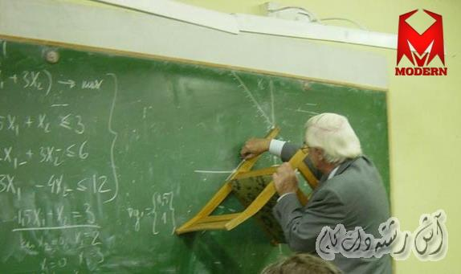
Ý˜ï¿½ï¿½ ï¿½ È˜ï¿½ ï¿½ï¿½ ï¿½ï¿½ ï¿½ï¿½ï¿½ï¿½ ï¿½ï¿½ï¿½ï¿½ï¿½ ï¿½ï¿½ï¿½!
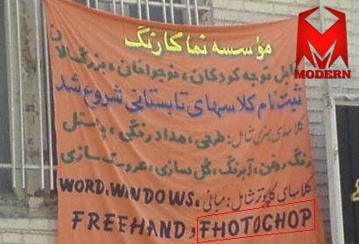
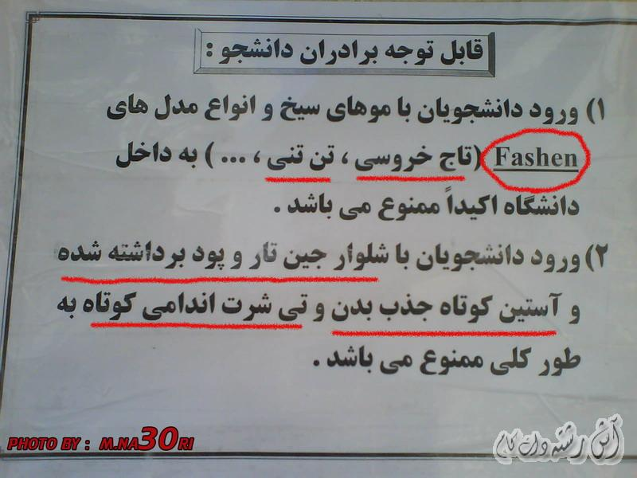
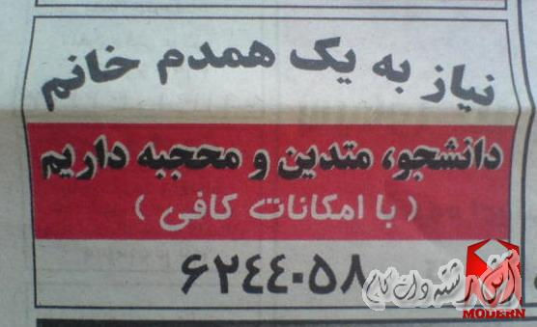
ï¿½ ï¿½ï¿½ï¿½ï¿½ï¿½ ï¿½ï¿½ï¿½!
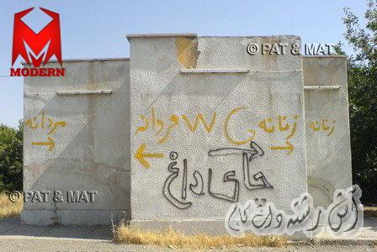
ï¿½ï¿½ï¿½ï¿½ï¿½ï¿½ï¿½ ï¿½ï¿½ï¿½ ï¿½ï¿½ï¿½ï¿½!
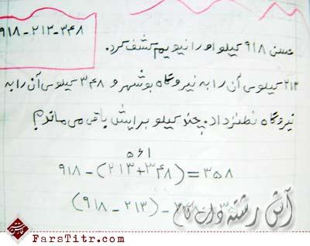
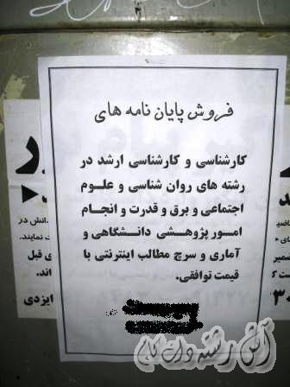
ï¿½ï¿½ï¿½ï¿½ï¿½ ï¿½ï¿½ï¿½ï¿½ï¿½ï¿½ ï¿½ï¿½ ï¿½ï¿½ï¿½ï¿½ï¿½ï¿½ï¿½ ï¿½ ï¿½ï¿½ï¿½ï¿½ï¿½ï¿½ï¿½ ï¿½ï¿½ï¿½ï¿½!
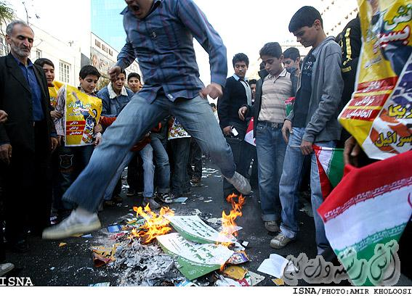
ï¿½ï¿½ï¿½ ï¿½ï¿½ï¿½ï¿½ï¿½ï¿½ï¿½ ï¿½ï¿½ ï¿½ï¿½ï¿½ï¿½ï¿½ï¿½ï¿½!
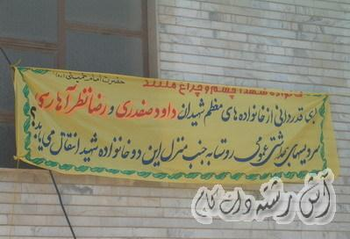
ï¿½ï¿½ï¿½ ï¿½ï¿½ ï¿½ï¿½ï¿½ï¿½ ï¿½ï¿½ ï¿½ï¿½ï¿½ï¿½ï¿½ ï¿½ï¿½ï¿½ï¿½ï¿½ ï¿½ï¿½ï¿½Ê¿!
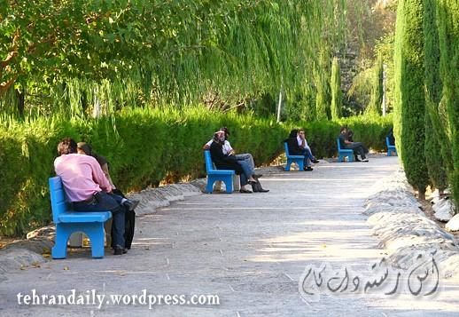
ï¿½ï¿½ ï¿½ï¿½ï¿½ï¿½ ï¿½ï¿½ï¿½ ï¿½ï¿½ï¿½ï¿½!
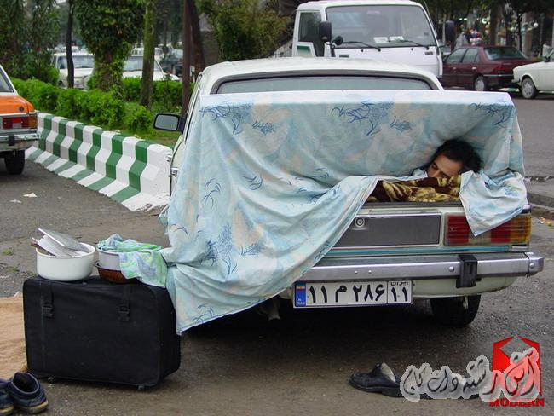
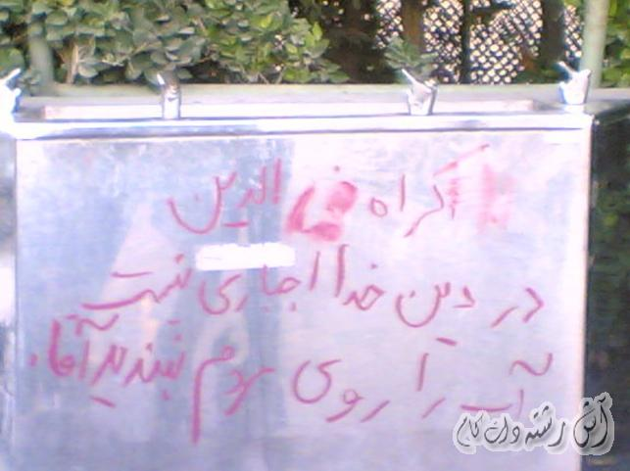
ï¿½ï¿½ï¿½ ï¿½ï¿½ï¿½ï¿½ï¿½ ï¿½ï¿½ï¿½ï¿½ï¿½ï¿½!
ï¿½ï¿½ï¿½ï¿½ ï¿½ï¿½ï¿½ï¿½ ï¿½ï¿½ï¿½ï¿½ ï¿½ï¿½ï¿½ï¿½ ï¿½ï¿½ ï¿½ï¿½ï¿½ï¿½ï¿½ï¿½ ï¿½ï¿½ï¿½ï¿½ï¿½ï¿½!
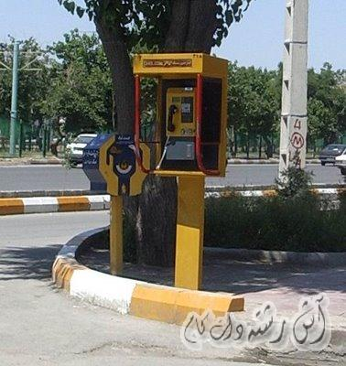
ï¿½ï¿½ ï¿½ï¿½ï¿½ï¿½ ï¿½ï¿½ ï¿½ï¿½ ï¿½ï¿½Ñï¿½ï¿½ï¿½ï¿½ ï¿½ï¿½ï¿½ï¿½ï¿½ï¿½ï¿½ï¿½ ï¿½ï¿½ï¿½ï¿½ï¿½ ï¿½ï¿½ï¿½ ï¿½ï¿½ ï¿½ï¿½ï¿½ï¿½ ï¿½ï¿½ï¿½ï¿½Ê¿!
